Covid-19 - Facts

- This virus is very infectious, but 80% of people have mild flu-like symptoms and don’t require hospitalization.
- Incubation (time between being exposed and showing symptoms) is 2-14 days.
- Virus spreads through respiratory droplets (coughing & sneezing).
- Pre-planning and good communication is the key to protect individuals and businesses.
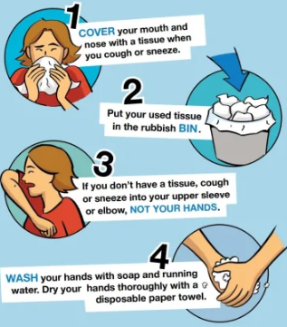

- It may be possible that a person can get COVID-19 by touching a surface or object that has the virus on it and then touching their mouth, nose, or possibly eyes, but this is not thought to be the main way the virus spreads. In studies, the virus can survive in the air for 4 hours. The virus survives best on plastic and stainless steel; it could still be detected up to 72 hours, although the numbers were drastically reduced. It only lives on cardboard for about 24 hours. https://www.medrxiv.org/content/10.1101/2020.03.09.20033217v2.full.pdf

- There are no nationwide shortages of food, although in some cases the inventory of certain foods at your grocery store might be temporarily low before stores can restock.

- The people are at higher risk of getting very sick from this illness includes:
  - Older adults (>70 years old)
  - Individuals with compromised immune systems
  - Individuals who have serious chronic medical conditions like: Heart disease, Diabetes, Lung disease

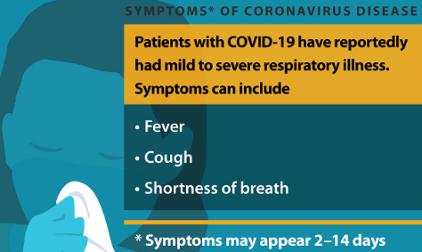
- If you become sick: https://www.cdc.gov/coronavirus/2019-ncov/downloads/sick-with-2019-nCoV-fact-sheet.pdf
  - Stay at home. Recommend self-quarantine for 14 days.
  - Treat with over the counter flu medicine (decongestant, Tylenol for fever, cough medicine, etc.)
  - Don’t go to hospital unless symptoms become severe or you are at risk.

