Covid-19 – Tips for Businesses

- Post guidance to prevent employees from getting sick.

- Sanitize hands and high-traffic surfaces (door knobs, handrails) with alcohol-based sanitizer. https://www.epa.gov/pesticide-registration/list-n-disinfectants-use-against-sars-cov-2

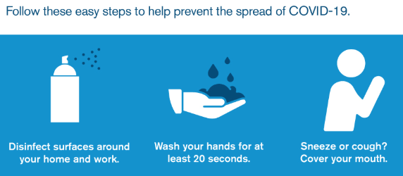
- If an employee is confirmed to have COVID-19, employers should inform fellow employees of their possible exposure to COVID-19 in the workplace but maintain confidentiality. Sick employees should follow the CDC’s What to do if you are sick with coronavirus disease 2019 (COVID-19). Employers should consult with the local health department for additional guidance.

- Keep an eye on changing legislation and travel restrictions

- Set calm, informed tone with employees with regular communication to protect themselves and the business.

- Instruct employees to report to their supervisor or HR if they show symptoms.

- Few potential guidelines to help keep employees safe:
  - Enforce anyone who is sick to stay home
  - Cancel any nonessential visitors or customer visits to the facility
  - Cancel any up upcoming trips for our team even if they are domestic.
  - Identified our higher-risk employees and change the way they work. For example, our warehouse crew is no longer being outside when the truck driver or customer is outside.
  - They are leaving the product on the dock and monitoring through a camera.
All doors are to remain closed if someone needs to come in they are calling a number and being screened to be authorized inside.

- Prepare contingency and mitigation Plans with upper management (legal counsel, HR, key stakeholders) to determine logic for possible scenarios:
  - Work from home
  - Temporary relaxing certain work rules around sick leave / Employees out of sick leave
  - Assured supply of raw materials
  - Lack of PPE (masks, gloves)
  - Business travel
  - Proper training of employees to conduct medical screening, clean-up, and/or use of PPE
  - Someone claims to be sick from work (not an OSHA recordable)

